**PTAX Enrolment Module for Tax Payer**

**First Step (Personal Details):**

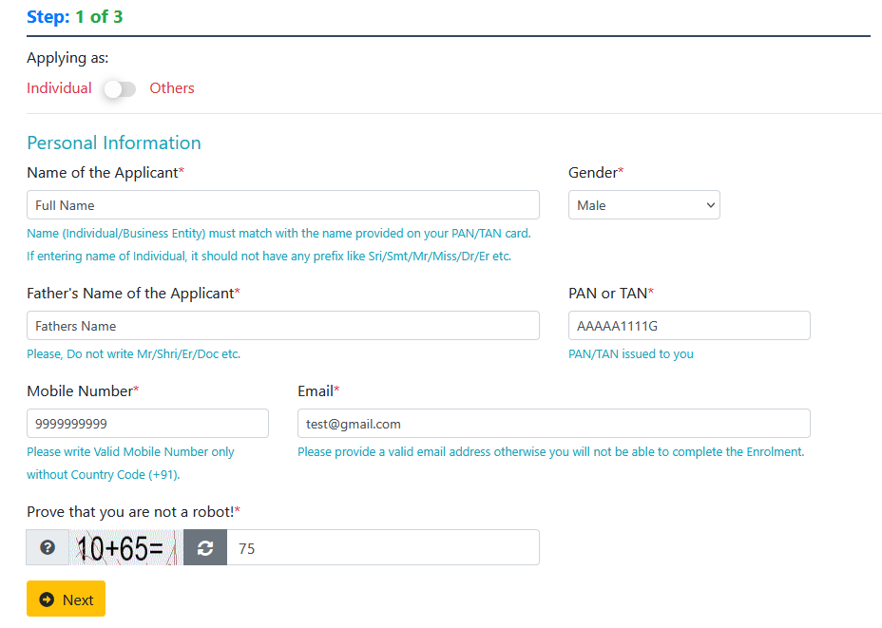

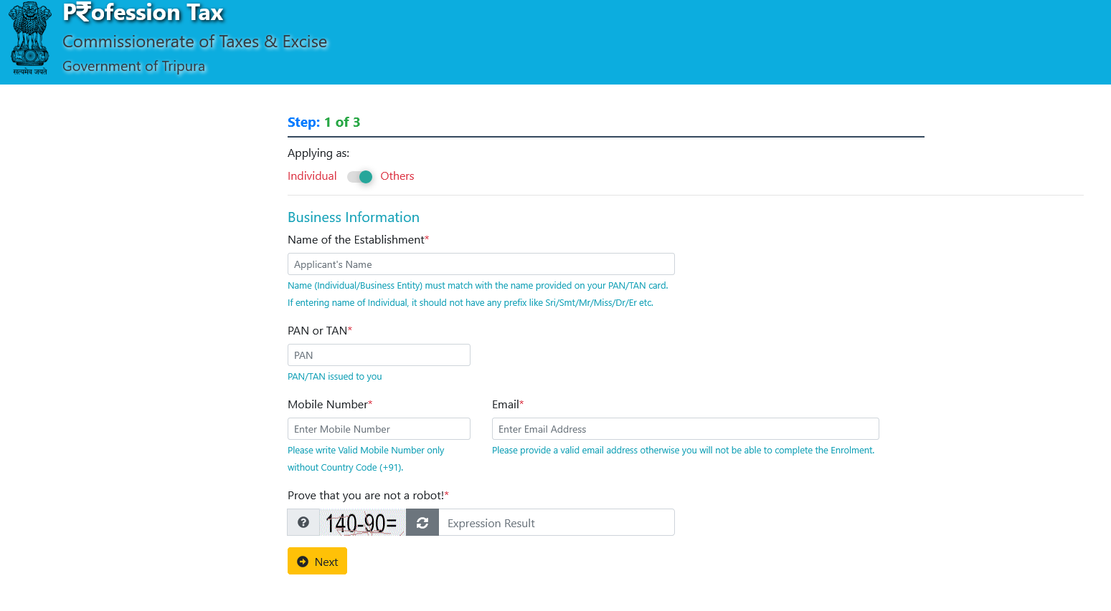

**Second Step (OTP Verification using Mobile Number):**

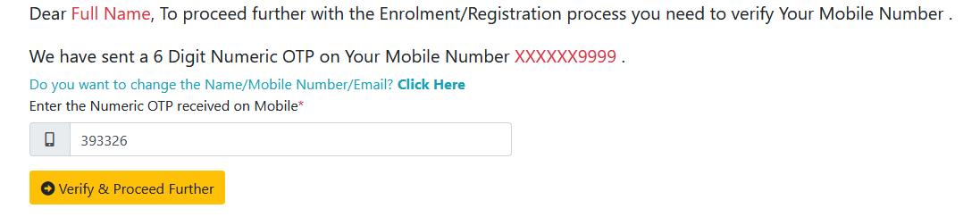

**Third Step (Establishment Information):**

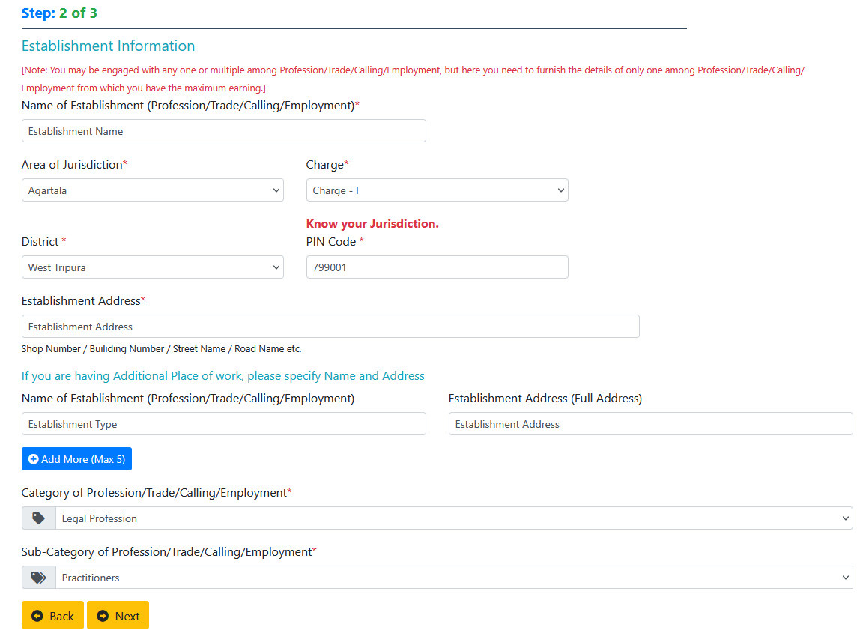

**Fourth Step (Chose Establishment Type):**



**Fifth Step (Profession):**

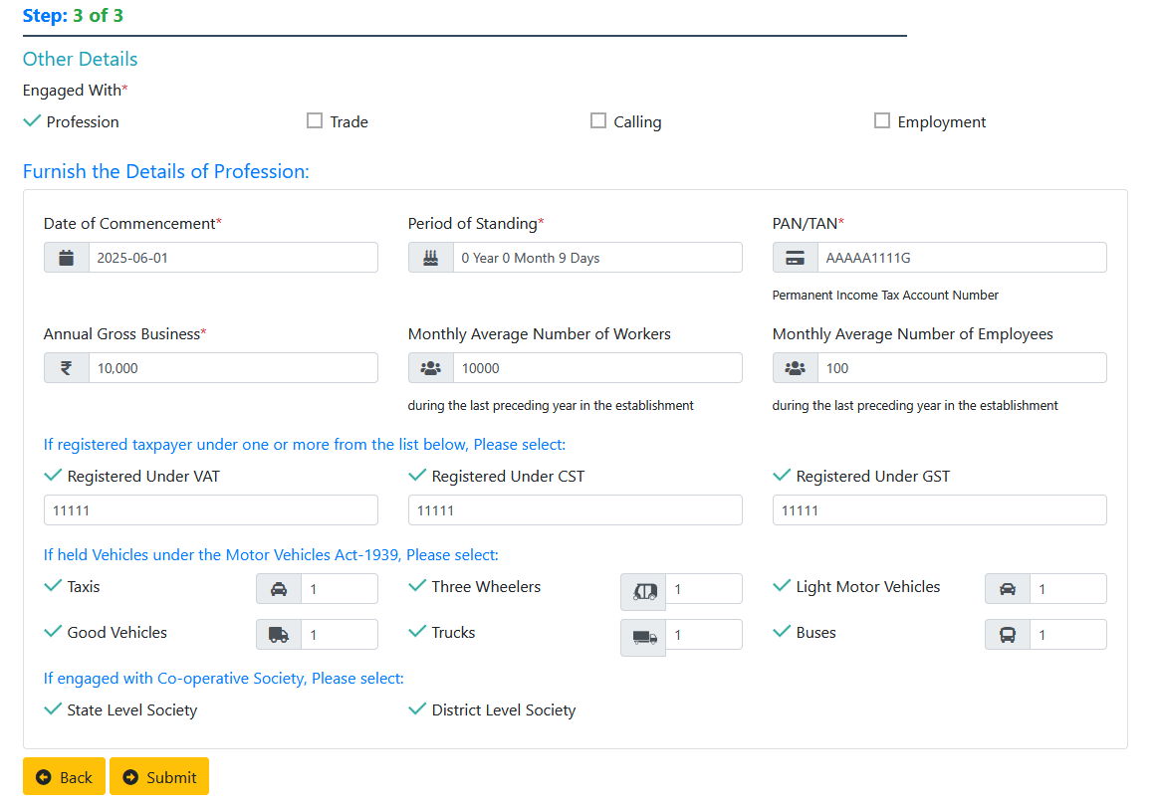

**Fifth Step (Trade):**

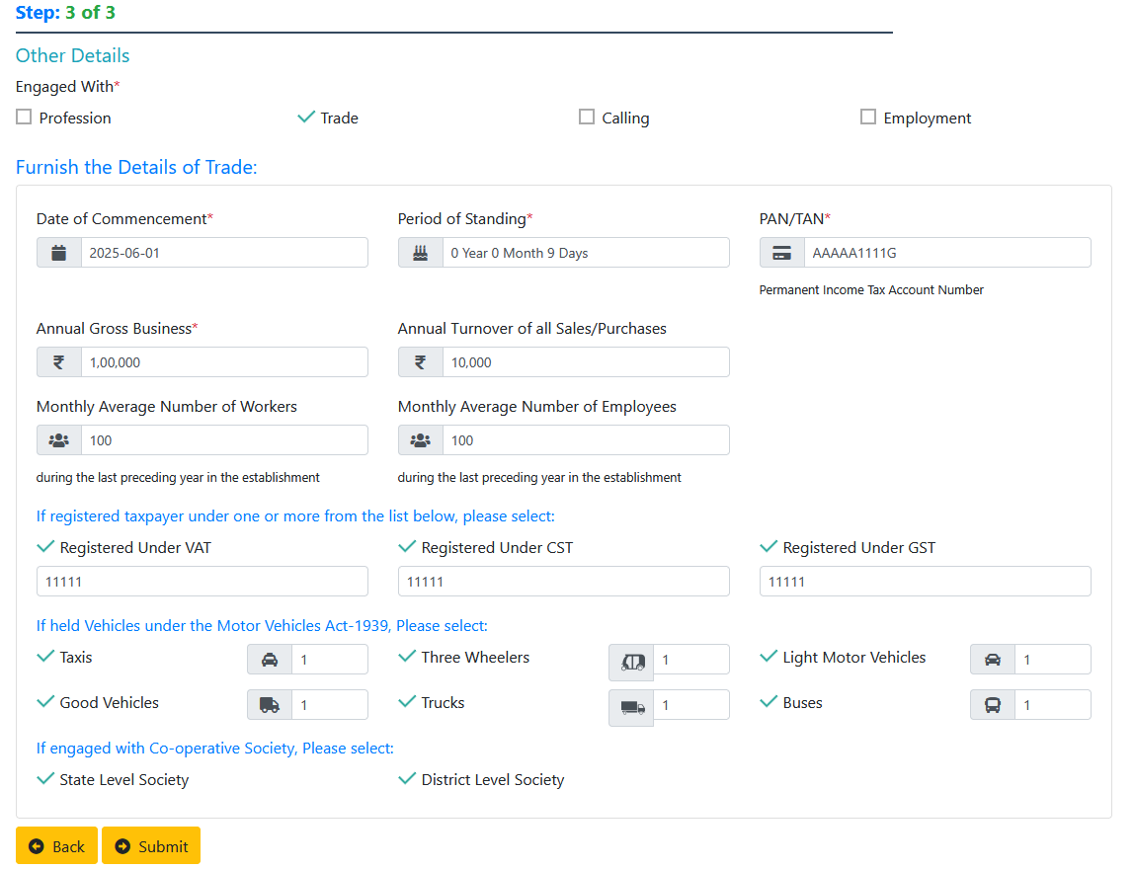

**Fifth Step (Calling):**

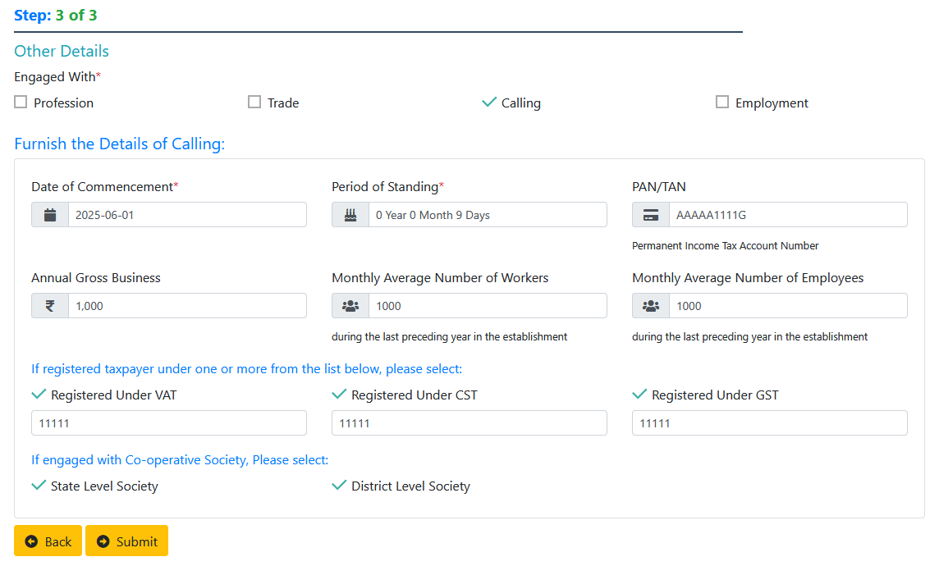

**Fifth Step (Employment):**

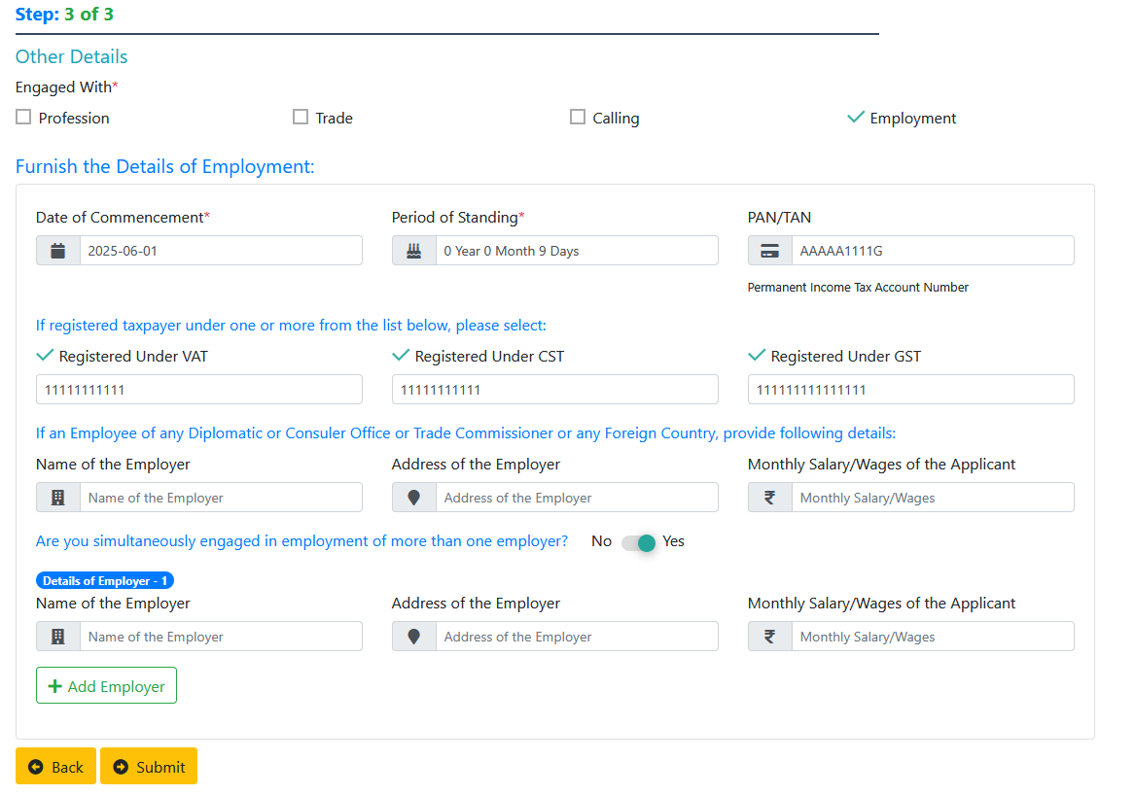

**Sixth Step (Check Details & Final Submit with Captcha):**

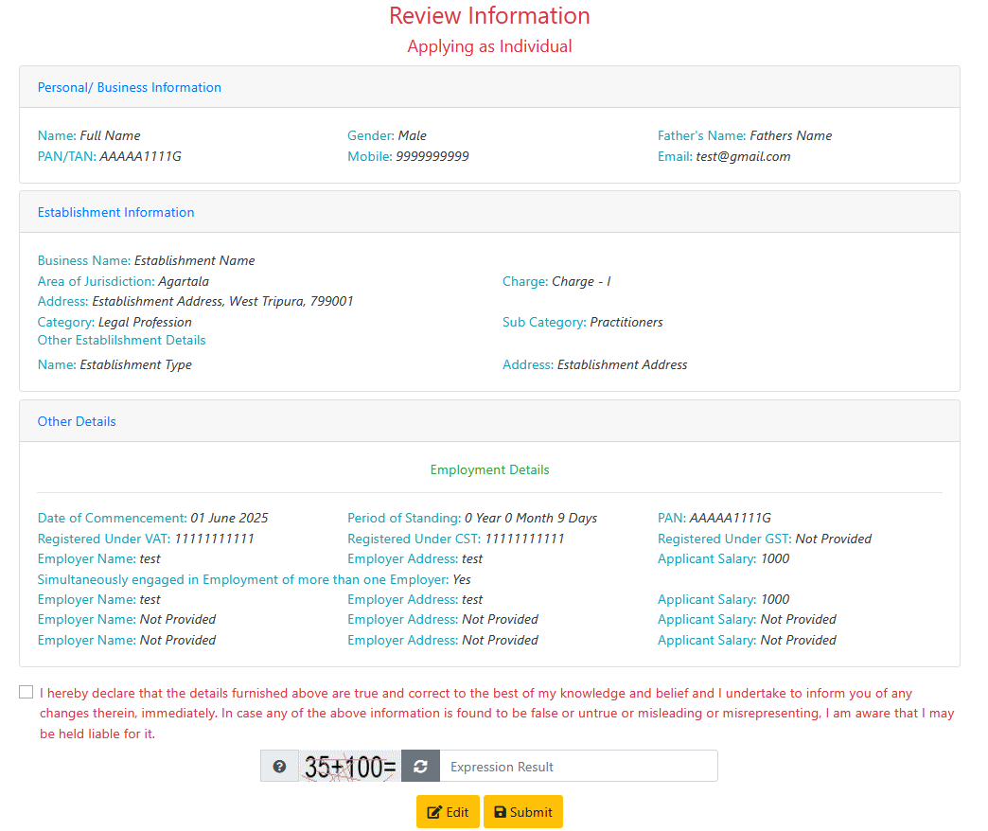

**Seventh Step (OTP Verification using Mobile Number):**

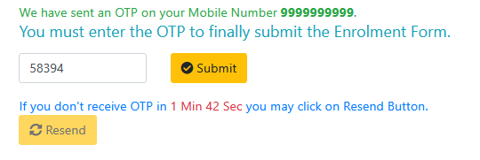

**Eight Step (Confirmation Message):**

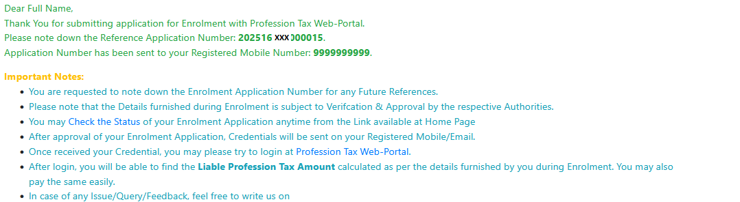

**Table Structure (Schema Name: ptax)**

**Table1: mtbl_users_taxpayers**

**Sequence**

CREATE SEQUENCE IF NOT EXISTS ptax.mtbl_users_taxpayers_rsn_mstbl_users_seq

INCREMENT 1

START 1

MINVALUE 1

MAXVALUE 2147483647

CACHE 1;

**Table**

CREATE TABLE IF NOT EXISTS ptax.mtbl_users_taxpayers

(

rsn_mstbl_users integer NOT NULL DEFAULT nextval('ptax.mtbl_users_taxpayers_rsn_mstbl_users_seq'::regclass),

userid character varying(15) COLLATE pg_catalog."default",

username character varying(100) COLLATE pg_catalog."default",

mobile character(10) COLLATE pg_catalog."default",

email character varying(100) COLLATE pg_catalog."default",

area_code character varying(3) COLLATE pg_catalog."default",

charge_code character varying(4) COLLATE pg_catalog."default",

userpassword character varying(64) COLLATE pg_catalog."default",

userroleid integer,

date_last_sucessfull_login timestamp without time zone,

date_last_failure_login timestamp without time zone,

count_failed_login_attempt integer NOT NULL,

is_locked boolean NOT NULL,

is_deleted boolean NOT NULL,

date_creation timestamp without time zone NOT NULL,

userid_createdby character varying(15) COLLATE pg_catalog."default",

created_from_ipv4 character varying(15) COLLATE pg_catalog."default",

date_modification timestamp without time zone,

userid_modifiedby character varying(15) COLLATE pg_catalog."default",

modified_from_ipv4 character varying(15) COLLATE pg_catalog."default",

date_deletion timestamp without time zone,

userid_deletedby character varying(15) COLLATE pg_catalog."default",

deleted_from_ipv4 character varying(15) COLLATE pg_catalog."default",

date_last_password_change timestamp without time zone,

remarks character varying(100) COLLATE pg_catalog."default",

deletion_remarks character varying(150) COLLATE pg_catalog."default",

updated_by character varying(15) COLLATE pg_catalog."default",

updated_on timestamp without time zone,

updated_from_ipv4 character varying(15) COLLATE pg_catalog."default",

updation_remarks character varying(150) COLLATE pg_catalog."default",

CONSTRAINT mtbl_users_taxpayers_pkey PRIMARY KEY (rsn_mstbl_users)

)

**Table2: ttbl_applicant_enrolment_details**

**Sequence**

CREATE SEQUENCE IF NOT EXISTS ptax.ttbl_applicant_enrolment_details_rsn_seq

INCREMENT 1

START 1

MINVALUE 1

MAXVALUE 9223372036854775807

CACHE 1;

**Table**

CREATE TABLE IF NOT EXISTS ptax.ttbl_applicant_enrolment_details

(

rsn bigint NOT NULL DEFAULT nextval('ptax.ttbl_applicant_enrolment_details_rsn_seq'::regclass),

application_id character varying(15) COLLATE pg_catalog."default",

ptan character varying(10) COLLATE pg_catalog."default",

name character varying(100) COLLATE pg_catalog."default",

gender character(1) COLLATE pg_catalog."default",

father_name character varying(100) COLLATE pg_catalog."default",

mobile character(10) COLLATE pg_catalog."default",

email character varying(100) COLLATE pg_catalog."default",

business_name character varying(200) COLLATE pg_catalog."default",

jurisdiction_code character varying(3) COLLATE pg_catalog."default",

charge_code character varying(4) COLLATE pg_catalog."default",

address_text character varying(100) COLLATE pg_catalog."default",

subdisctrict_lgd_code integer,

district_lgd_code integer,

pincode character(6) COLLATE pg_catalog."default",

ptax_category integer,

ptax_subcategory integer,

engaged_with_profession boolean,

engaged_with_trade boolean,

engaged_with_calling boolean,

engaged_with_employement boolean,

pan character(10) COLLATE pg_catalog."default",

inserted_on timestamp without time zone,

inserted_by character varying(15) COLLATE pg_catalog."default",

inserted_from_ipv4 character varying(15) COLLATE pg_catalog."default",

welcome_sms_count integer,

welcome_email_count integer,

establishment1_name character varying(100) COLLATE pg_catalog."default",

establishment1_address character varying(100) COLLATE pg_catalog."default",

establishment2_name character varying(100) COLLATE pg_catalog."default",

establishment2_address character varying(100) COLLATE pg_catalog."default",

establishment3_name character varying(100) COLLATE pg_catalog."default",

establishment3_address character varying(100) COLLATE pg_catalog."default",

establishment4_name character varying(100) COLLATE pg_catalog."default",

establishment4_address character varying(100) COLLATE pg_catalog."default",

establishment5_name character varying(100) COLLATE pg_catalog."default",

establishment5_address character varying(100) COLLATE pg_catalog."default",

applying_as_individual boolean,

CONSTRAINT ttbl_applicant_enrolment_details_pkey PRIMARY KEY (rsn)

)

**Table3: ttbl_applicant_profession_details**

**Sequence**

CREATE SEQUENCE IF NOT EXISTS ptax.ttbl_applicant_profession_details_rsn_seq

INCREMENT 1

START 1

MINVALUE 1

MAXVALUE 9223372036854775807

CACHE 1;

**Table**

CREATE TABLE IF NOT EXISTS ptax.ttbl_applicant_profession_details

(

rsn bigint NOT NULL DEFAULT nextval('ptax.ttbl_applicant_profession_details_rsn_seq'::regclass),

application_id character varying(15) COLLATE pg_catalog."default",

ptan character varying(12) COLLATE pg_catalog."default",

commencement_date date,

period_of_standing character varying(50) COLLATE pg_catalog."default",

pan character(10) COLLATE pg_catalog."default",

annual_gross_business numeric(18,2),

avg_workers_monthly integer,

avg_employees_monthly integer,

vat_number character varying(11) COLLATE pg_catalog."default",

cst_number character varying(11) COLLATE pg_catalog."default",

gst_number character varying(15) COLLATE pg_catalog."default",

taxi_count integer,

three_wheeler_count integer,

lmv_count integer,

good_vehicle_count integer,

truck_count integer,

bus_count integer,

engaged_with_state_society boolean,

engaged_with_district_society boolean,

inserted_on timestamp without time zone,

inserted_by character varying(50) COLLATE pg_catalog."default",

inserted_from_ipv4 character varying(15) COLLATE pg_catalog."default",

updated_on timestamp without time zone,

updated_by character varying(50) COLLATE pg_catalog."default",

updated_from_ipv4 character varying(15) COLLATE pg_catalog."default",

CONSTRAINT ttbl_applicant_profession_details_pkey PRIMARY KEY (rsn)

)

**Table4: ttbl_applicant_trade_details**

**Sequence**

CREATE SEQUENCE IF NOT EXISTS ptax.ttbl_applicant_trade_details_rsn_seq

INCREMENT 1

START 1

MINVALUE 1

MAXVALUE 9223372036854775807

CACHE 1;

**Table**

CREATE TABLE IF NOT EXISTS ptax.ttbl_applicant_trade_details

(

rsn bigint NOT NULL DEFAULT nextval('ptax.ttbl_applicant_trade_details_rsn_seq'::regclass),

application_id character varying(15) COLLATE pg_catalog."default",

ptan character varying(10) COLLATE pg_catalog."default",

commencement_date date,

period_of_standing character varying(50) COLLATE pg_catalog."default",

pan character(10) COLLATE pg_catalog."default",

annual_gross_business numeric(18,2),

annual_turn_over numeric(18,2),

avg_workers_monthly integer,

avg_employees_monthly integer,

vat_number character varying(11) COLLATE pg_catalog."default",

cst_number character varying(11) COLLATE pg_catalog."default",

gst_number character varying(15) COLLATE pg_catalog."default",

taxi_count integer,

three_wheeler_count integer,

lmv_count integer,

good_vehicle_count integer,

truck_count integer,

bus_count integer,

engaged_with_state_society boolean,

engaged_with_district_society boolean,

inserted_on timestamp without time zone,

inserted_by character varying(50) COLLATE pg_catalog."default",

inserted_from_ipv4 character varying(15) COLLATE pg_catalog."default",

updated_on timestamp without time zone,

updated_by character varying(50) COLLATE pg_catalog."default",

updated_from_ipv4 character varying(15) COLLATE pg_catalog."default",

CONSTRAINT ttbl_applicant_trade_details_pkey PRIMARY KEY (rsn)

)

**Table5: ttbl_applicant_calling_details**

**Sequence**

CREATE SEQUENCE IF NOT EXISTS ptax.ttbl_applicant_calling_details_rsn_seq

INCREMENT 1

START 1

MINVALUE 1

MAXVALUE 9223372036854775807

CACHE 1;

**Table**

CREATE TABLE IF NOT EXISTS ptax.ttbl_applicant_calling_details

(

rsn bigint NOT NULL DEFAULT nextval('ptax.ttbl_applicant_calling_details_rsn_seq'::regclass),

application_id character varying(15) COLLATE pg_catalog."default",

ptan character varying(10) COLLATE pg_catalog."default",

commencement_date date,

period_of_standing character varying(50) COLLATE pg_catalog."default",

pan character(10) COLLATE pg_catalog."default",

annual_gross_business numeric(18,2),

avg_workers_monthly integer,

avg_employees_monthly integer,

vat_number character varying(11) COLLATE pg_catalog."default",

cst_number character varying(11) COLLATE pg_catalog."default",

gst_number character varying(15) COLLATE pg_catalog."default",

engaged_with_state_society boolean,

engaged_with_district_society boolean,

inserted_on timestamp without time zone,

inserted_by character varying(50) COLLATE pg_catalog."default",

inserted_from_ipv4 character varying(15) COLLATE pg_catalog."default",

updated_on timestamp without time zone,

updated_by character varying(50) COLLATE pg_catalog."default",

updated_from_ipv4 character varying(15) COLLATE pg_catalog."default",

CONSTRAINT ttbl_applicant_calling_details_pkey PRIMARY KEY (rsn)

)

**Table6: ttbl_applicant_employment_details**

**Sequence**

CREATE SEQUENCE IF NOT EXISTS ptax.ttbl_applicant_employment_details_rsn_seq

INCREMENT 1

START 1

MINVALUE 1

MAXVALUE 9223372036854775807

CACHE 1;

**Table**

CREATE TABLE IF NOT EXISTS ptax.ttbl_applicant_employment_details

(

rsn bigint NOT NULL DEFAULT nextval('ptax.ttbl_applicant_employment_details_rsn_seq'::regclass),

application_id character varying(15) COLLATE pg_catalog."default",

ptan character varying(10) COLLATE pg_catalog."default",

commencement_date date,

period_of_standing character varying(50) COLLATE pg_catalog."default",

pan character(10) COLLATE pg_catalog."default",

vat_number character varying(11) COLLATE pg_catalog."default",

cst_number character varying(11) COLLATE pg_catalog."default",

gst_number character varying(15) COLLATE pg_catalog."default",

employer_name character varying(150) COLLATE pg_catalog."default",

employer_address character varying(150) COLLATE pg_catalog."default",

monthly_salary numeric(18,2),

engaged_with_multiple_employer boolean,

employer_name1 character varying(150) COLLATE pg_catalog."default",

employer_address1 character varying(150) COLLATE pg_catalog."default",

monthly_salary1 numeric(18,2),

employer_name2 character varying(150) COLLATE pg_catalog."default",

employer_address2 character varying(150) COLLATE pg_catalog."default",

monthly_salary2 numeric(18,2),

employer_name3 character varying(150) COLLATE pg_catalog."default",

employer_address3 character varying(150) COLLATE pg_catalog."default",

monthly_salary3 numeric(18,2),

inserted_on timestamp without time zone,

inserted_by character varying(50) COLLATE pg_catalog."default",

inserted_from_ipv4 character varying(15) COLLATE pg_catalog."default",

updated_on timestamp without time zone,

updated_by character varying(50) COLLATE pg_catalog."default",

updated_from_ipv4 character varying(15) COLLATE pg_catalog."default",

CONSTRAINT ttbl_applicant_employment_details_pkey PRIMARY KEY (rsn)

)

**Table7: ttbl_enrolment_application_status**

**Sequence**

CREATE SEQUENCE IF NOT EXISTS ptax.ttbl_enrolment_application_status_rsn_seq

INCREMENT 1

START 1

MINVALUE 1

MAXVALUE 9223372036854775807

CACHE 1;

**Table**

CREATE TABLE IF NOT EXISTS ptax.ttbl_enrolment_application_status

(

rsn bigint NOT NULL DEFAULT nextval('ptax.ttbl_enrolment_application_status_rsn_seq'::regclass),

application_id character varying(15) COLLATE pg_catalog."default",

ptan character varying(12) COLLATE pg_catalog."default",

is_viewed boolean,

viewed_on timestamp without time zone,

viewed_by character varying(15) COLLATE pg_catalog."default",

viewed_from_ipv4 character varying(15) COLLATE pg_catalog."default",

is_forwarded boolean,

forwarded_on timestamp without time zone,

forwarded_to character varying(15) COLLATE pg_catalog."default",

forwarded_by character varying(15) COLLATE pg_catalog."default",

forwarded_from_ipv4 character varying(15) COLLATE pg_catalog."default",

forwarding_remarks character varying(500) COLLATE pg_catalog."default",

is_inspected boolean,

inspected_on timestamp without time zone,

inspected_by character varying(15) COLLATE pg_catalog."default",

inspected_from_ipv4 character varying(15) COLLATE pg_catalog."default",

inspected_remarks character varying(500) COLLATE pg_catalog."default",

is_approved boolean,

approved_on timestamp without time zone,

approved_by character varying(15) COLLATE pg_catalog."default",

approved_from_ipv4 character varying(15) COLLATE pg_catalog."default",

approval_remarks character varying(500) COLLATE pg_catalog."default",

is_rejected boolean,

rejected_on timestamp without time zone,

rejected_by character varying(15) COLLATE pg_catalog."default",

rejected_from_ipv4 character varying(15) COLLATE pg_catalog."default",

rejection_remarks character varying(250) COLLATE pg_catalog."default",

CONSTRAINT ttbl_enrolment_application_status_pkey PRIMARY KEY (rsn)

)

**Master Table 1: mas_district**

CREATE TABLE IF NOT EXISTS ptax.mas_district

(

district_lgd_code integer NOT NULL,

district_name character varying(50) COLLATE pg_catalog."default" NOT NULL,

local_code integer,

CONSTRAINT mas_district_pkey PRIMARY KEY (district_lgd_code)

)

**Master Table 2: mtbl_area**

CREATE TABLE IF NOT EXISTS ptax.mtbl_area

(

code character(3) COLLATE pg_catalog."default",

name_en character varying(50) COLLATE pg_catalog."default",

name_bn character varying(100) COLLATE pg_catalog."default"

)

**Master Table 3: mtbl_charge**

CREATE TABLE IF NOT EXISTS ptax.mtbl_charge

(

code character varying(4) COLLATE pg_catalog."default",

charge character varying(255) COLLATE pg_catalog."default",

area_code character(3) COLLATE pg_catalog."default",

charge_sn integer

)

**Master Table 4: mtbl_role**

CREATE TABLE IF NOT EXISTS ptax.mtbl_role

(

role_id integer NOT NULL,

designation_code character varying(10) COLLATE pg_catalog."default",

role_name character varying(25) COLLATE pg_catalog."default",

role_name_ll character varying(50) COLLATE pg_catalog."default",

outside_visibility boolean,

CONSTRAINT mtbl_role_pkey PRIMARY KEY (role_id)

)

**Master Table 5: mtbl_ptax_category**

**Sequence**

CREATE SEQUENCE IF NOT EXISTS ptax.mtbl_ptax_category_cat_rsn_seq

INCREMENT 1

START 1

MINVALUE 1

MAXVALUE 2147483647

CACHE 1;

**Table**

CREATE TABLE IF NOT EXISTS ptax.mtbl_ptax_category

(

cat_rsn integer NOT NULL DEFAULT nextval('ptax.mtbl_ptax_category_cat_rsn_seq'::regclass),

cat_id integer,

cat_description character varying(150) COLLATE pg_catalog."default",

CONSTRAINT mtbl_ptax_category_pkey PRIMARY KEY (cat_rsn)

)

**Master Table 6: mtbl_ptax_category_subcategory**

**Sequence**

CREATE SEQUENCE IF NOT EXISTS ptax.mtbl_ptax_category_subcategory_record_rsn_seq

INCREMENT 1

START 1

MINVALUE 1

MAXVALUE 2147483647

CACHE 1;

**Table**

CREATE TABLE IF NOT EXISTS ptax.mtbl_ptax_category_subcategory

(

record_rsn integer NOT NULL DEFAULT nextval('ptax.mtbl_ptax_category_subcategory_record_rsn_seq'::regclass),

cat_code integer,

cat_description character varying(150) COLLATE pg_catalog."default",

subcat_code integer,

subcat_description character varying(150) COLLATE pg_catalog."default",

is_visible boolean,

CONSTRAINT mtbl_ptax_category_subcategory_pkey PRIMARY KEY (record_rsn)

)